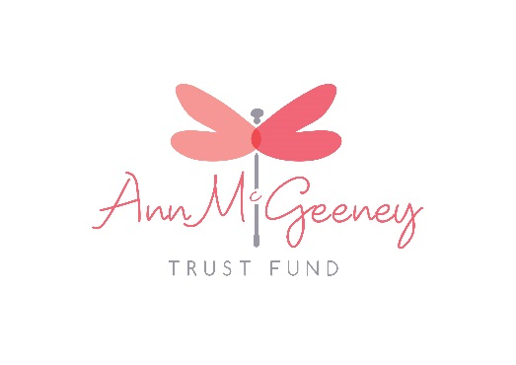

**Ann McGeeney Trust Fund Charity Ball**

17th October 2015



Contact us for more info; annmcgeeneytrustfund@hotmail.com

Phone; 07776152595

Tickets: £45.00/€65.00

Tables of 10 available

Available to buy from:

annmcgeeneytrustfund@hotmail.com

Venue: Crowne Plaza Hotel Dundalk

Time: 7:00pm

Ann Mc Geeney was born on the 3rd June in Cornonagh a small townland outside Crossmaglen in South Armagh, Ireland. Ann died on the 11th of September 2014 from cancer following a diagnosis in June the previous year. She had shown no signs of illness up to that point. Her life had been an exceptionally active one, running cycling, kayaking, walking her beloved hills. During her illness she never once allowed it to stop her both doing her work and continuing to exercise with family and friends.

In recognition of her life and work her family, friends and work associates agreed to establish the Ann Mc Geeney Charitable Trust. The Trust will seek to build a capital amount of funds and once established the interest arising from this will be given out in grant support.

The focus of the Trust will be in keeping with her principles and life. It will provide support for locally based peace building across and within communities; it will work across the border; it will provide support to women and women’s groups seeking to make a positive difference in their lives and the lives of others; it will support minority groups both indigenous and those newly arrived to Ireland.

The Trust will be administered though the Community Foundation for Northern Ireland (CFNI), a registered charity in Northern Ireland with years of expertise and experience in charitable trust management. It will be overseen by a policy and decision making panel drawn from her daughters, sisters, sisters in law and close friends. CFNI will provide technical and legal advice as required.

It is expected that it will take a couple of years to be able to generate the level of capital funds to generate the interest to enable grants to be made. Donations have already been committed and an annual Ann MC Geeney Charity Ball will be held to raise funds and awareness of the charity.